NAME : ANUHYA BHEEMIREDDY

// Execute these triggers on the database we created for phase 2.

**Trigger : 1** The trigger inserts the old event location in a new table before updating the event location on the event table.

Create a new table using the below query.

**CREATE TABLE event_loc_change_info (**

**ID int NOT NULL AUTO_INCREMENT,**

**Event_id int NOT NULL,**

**old_location varchar(255),**

**changedat DATETIME DEFAULT NULL,**

**PRIMARY KEY (ID)**

**)**

Then create the trigger using below query.

**Delimiter$$**

[**CREATE**](http://localhost/phpmyadmin/url.php?url=https://dev.mysql.com/doc/refman/5.5/en/create-trigger.html)[**TRIGGER**](http://localhost/phpmyadmin/url.php?url=https://dev.mysql.com/doc/refman/5.5/en/create-trigger.html)**before_event_update**

**BEFORE**[**UPDATE**](http://localhost/phpmyadmin/url.php?url=https://dev.mysql.com/doc/refman/5.5/en/update.html)**ON event**

**For each ROW**

**BEGIN**[**insert**](http://localhost/phpmyadmin/url.php?url=https://dev.mysql.com/doc/refman/5.5/en/insert.html)**INTO event_loc_change_info**[**set**](http://localhost/phpmyadmin/url.php?url=https://dev.mysql.com/doc/refman/5.5/en/set.html)**Event_id = OLD.Event_id, old_location = OLD.Location, changedat = NOW();**

**END $$**

**This is screen short when you update the location in event table .**

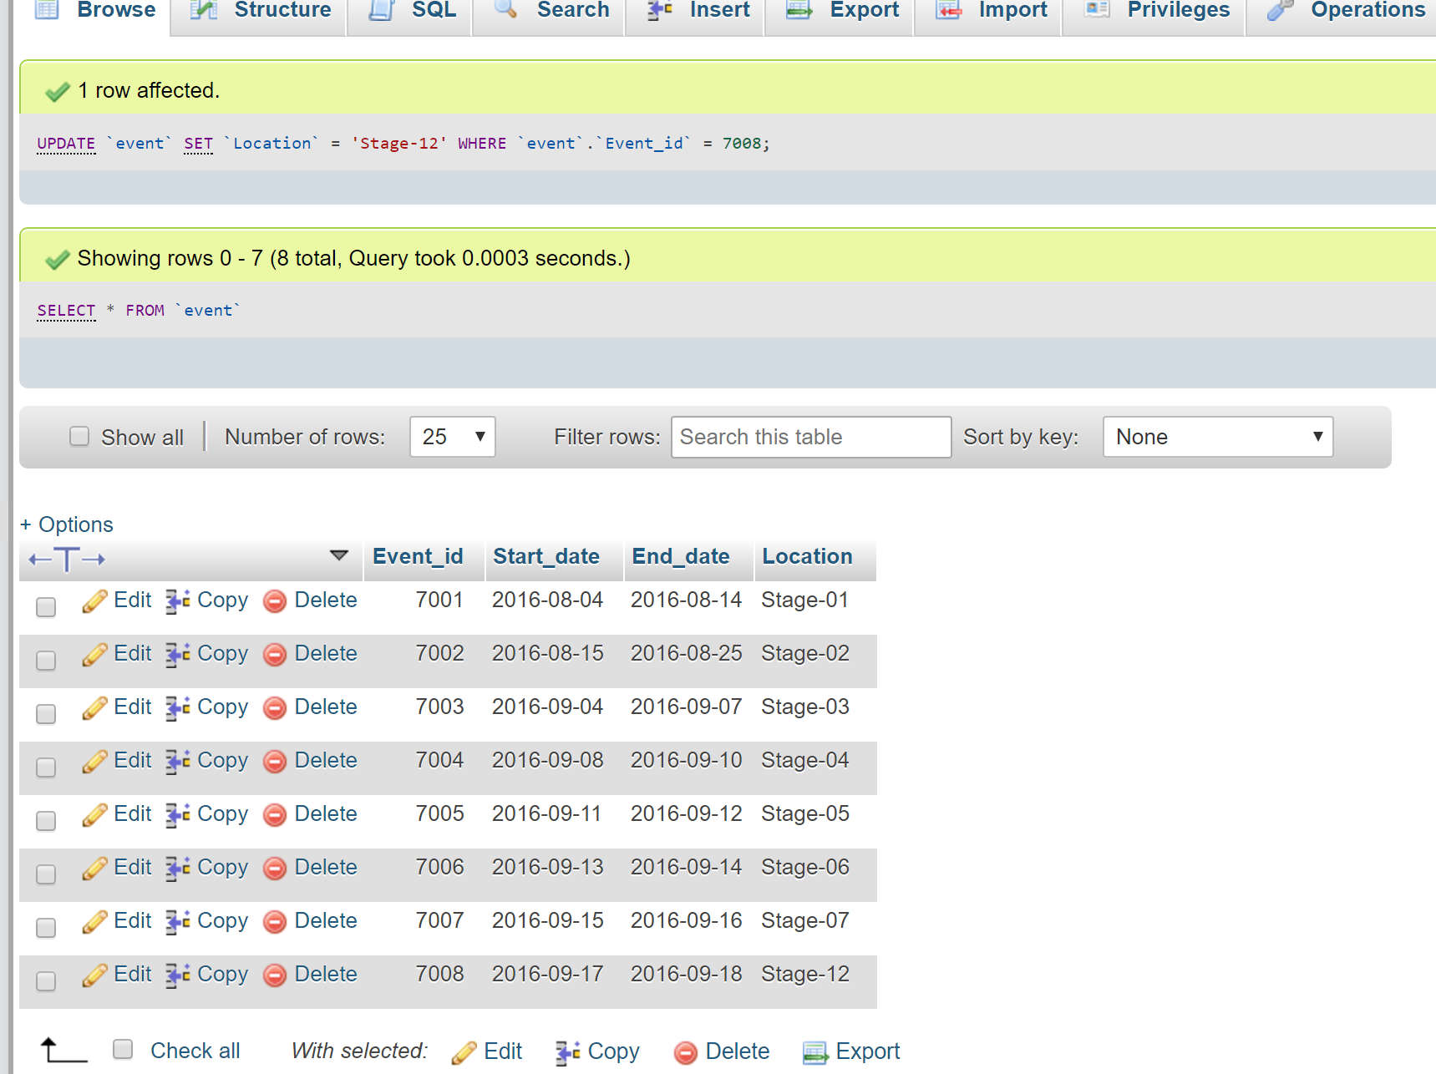

**This image is the execution of trigger i.e. whenever you update the event table location, event_loc_change_info table is going to store the old location of the updated event_id.**

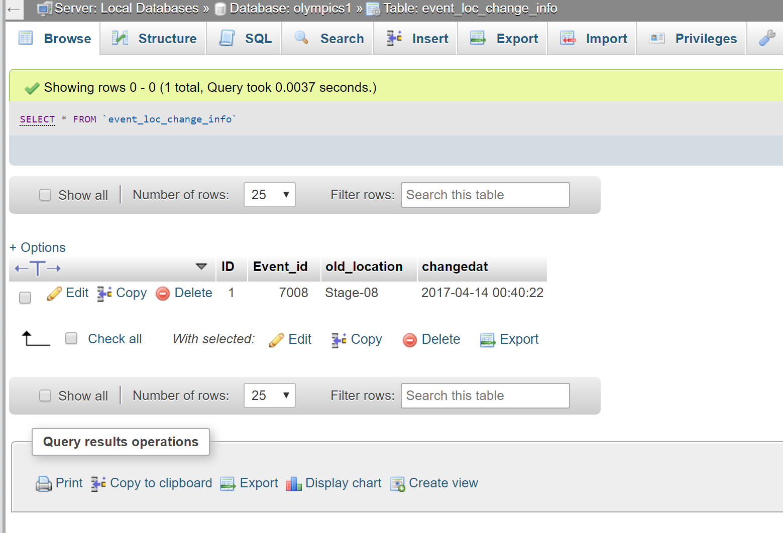

**Trigger : 2**

This trigger is a delete trigger. When you try to delete event_id in event table , it first deletes that event id in participate, event_official and event_loc_change_info tables and then deletes it from event table. This trigger avoids foreign key constraints while deleting an event_id from event table.

**DELIMITER $$**

**CREATE TRIGGER before_event_delete**

**BEFORE DELETE ON event**

**For each ROW**

**BEGIN**

**DELETE FROM event_loc_change_info**

**WHERE Event_id = OLD.Event_id;**

**DELETE FROM event_official WHERE Event_id = OLD.Event_id;**

**DELETE FROM participate WHERE Event_id = OLD.Event_id;**

**END$$**

When you execute the query:

Delete from event where Event_id =7008;

It deletes rows that contain Event_id = 7008 from participate, event_official and event_loc_change_info tables and then deletes the Event_id from event table to avoid foreign key constraints.

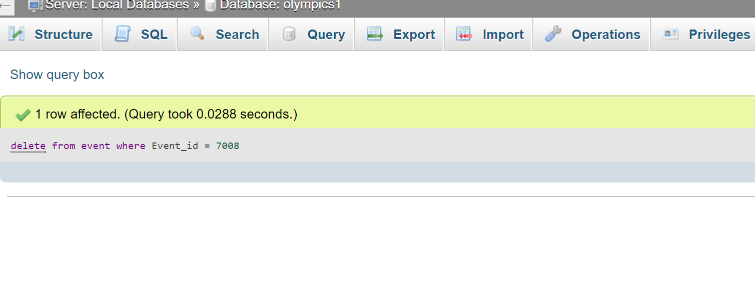

**The effected tables after the delete query is executed and you can see that none of the tables have event_id = 7008.**

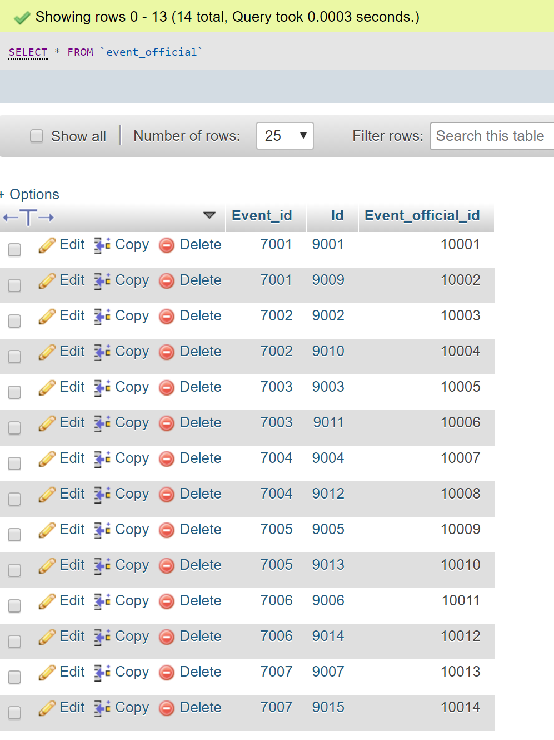y:

